Place Profiles Dashboard
Handover Documentation
NECS Consultancy

Contents
1 Background 3
2 Dashboard Files 3
2.1 Opening a copy locally 3
2.2 Composite R files 5
2.3 Backing data files 6
3 Hosting 7
3.1 Shiny IO 7
3.2 Uploading to Shiny IO 9
4 Common Issues 10
4.1 Values showing 'no data available' 10
4.2 Deployment issues 10

1 Background

The Place Profiles dashboard was created in response to a request from the Midlands team Place workstream. The Midlands team were copying and pasting data from Fingertips into a PowerPoint presentation which was massively inefficient and prone to errors. The Analytics team offered to develop a Shiny dashboard which utilised the FingertipsR package in R. This package can be used to load data from the Fingertips API into R for further use.
At the time of writing (26/02/2025) the lead for Place work in the Midlands team is Nav Chatha who has worked with me to provide feedback, QA the dashboard and suggest potential development work.
The dashboard was presented at the NHSR Conference in November 2024 and links to the slide and the recording can be found here, which give background information on the dashboard, a demo and some insight into issues faced with the dashboard.
- https://rbrown02.github.io/PlaceProfiles_Presentation/#/title-slide
- https://www.youtube.com/watch?v=SD_GZ1URYzI&t=213s @ 26 seconds

2 Dashboard Files

The dashboard files live in a repo in GitHub and so when making any changes to the dashboard, it is important to ensure these changes are fed back to GitHub.
Current link: https://github.com/rbrown02/Place_Profiles
The repo ownership will be transferred to the successor who will become the new owner, and the repo will have new link with their GitHub account name. The above link will continue to work and will redirect the user to the new repository location. If the repo is renamed, the redirect link will break.

2.1 Opening a copy locally

Best practice for making developments to an existing repo is to clone the repo, make the updates locally and then push the changes into the main branch of the repo. There are currently restrictions on the main branch that require and changes to be approved by the repo owner of collaborators. This means no changes should be made to the repo while it is being edited locally, preventing merge conflicts.
To open a copy locally, in the repo on GitHub.com, press the '<> Code' button and copy the link to your clipboard:
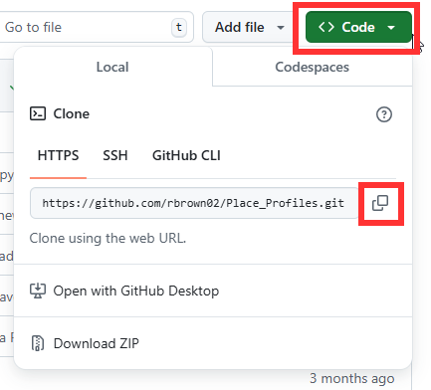
In RStudio (other IDEs are available), go to 'Open Project':
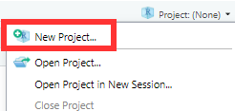

Select 'Version Control'
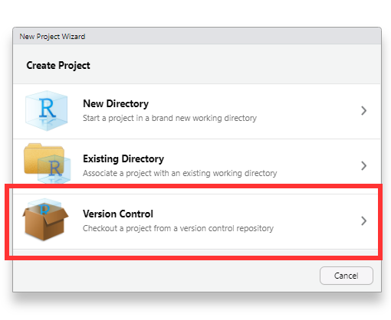

Then select 'Git':
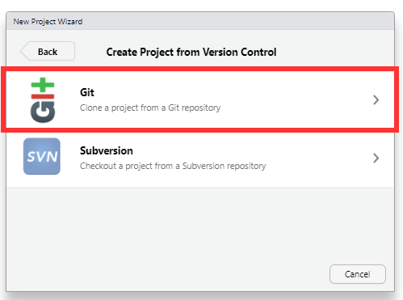
You can paste the 'Repository URL' copied from GitHub into the designated field, then specify a project directory name and location to store the repo locally.
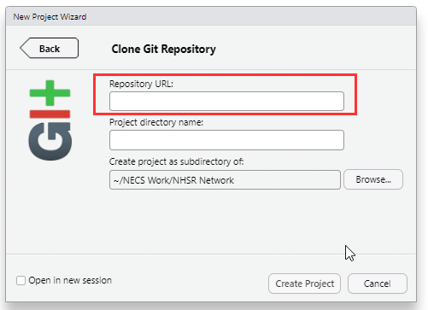
When you 'Create Project' it will clone the repository for you to be able to use locally.

2.2 Composite R files

- Data_Pull.R: this script calls in the necessary libraries, determines which data is to be collected based on indicator ID and calls the API from the FingertipsR package to pull the necessary data into a dataframe. The dataframe is filtered to retain only the latest data and, for certain indicators, to apply age-based filtering. Additionally, the script imports mapping data from CSV files in the repository and merges it with the Fingertips dataframe, so that users can filter by region in the final product.

- Population_Chart.R: this script defines a function to produce a population pyramid. The code is sourced from the FingertipsCharts package; however, due to difficulties loading the package in the dashboard, defining the function in this script and calling it in the server file resolves the issue.

- Themes.R: the themes script sets the default colours of the dashboard and also ensures links on the introduction page are functional.

- server.R: the server is a function which defines the functionality of the Shiny app. It sets the titles for the value boxes, configures filtering, renders value boxes, renders charts, renders tables and establishes the download functionality. The code is reactive, responding to filtering selections made by the end user.

- ui.R: the UI (User Interface) defines the appearance of the app. It includes all the text for the cover page and specifies the placement of outputs in the app.

- Shiny_DB_v5.R: this script responsible for calling the other scripts and creating the interactive web app, which will be launched locally when executed.

2.3 Backing data files

Files in the main folder:
- LA_metadata.csv: this data table data table maps regions and ICBs to the local government areas within each ICB. It is displayed in the 'Mappings' tab of the dashboard.

- Mappings.csv: this data table maps local government area names and codes to the region and the NHS region they fall under.

- Metadata.csv: this data table contains information about all the metrics displayed on the dashboard including the metric name, description and a link to the relevant page on Fingertips for more detailed information.

- population-by-ethnicity-and-local-authority-2021.csv: this data table contains population data by local government area and ethnicity, giving the proportion of each ethnicity comprising a local government area. This data is not available on Fingertips and is instead taken from: https://www.ons.gov.uk/peoplepopulationandcommunity/culturalidentity/ethnicity/bulletins/ethnicgroupenglandandwales/census2021. This data is from the census and will need to be updated when data for the next census is released (2031).

Filed in www folder:
- image2.png: NECS Consultancy logo

- styles.css: css file which defines the font styles and font sizes

3 Hosting

3.1 Shiny IO

The app is hosted on Shiny IO (https://www.shinyapps.io/). Users can sign up for a Shiny.io account and either create a new login or link their account to an existing GitHub account. The free tier allows users to publish up to 5 applications and have 25 active hours per month.
In RStudio, to link your Shiny account, go to Tools > Global Options
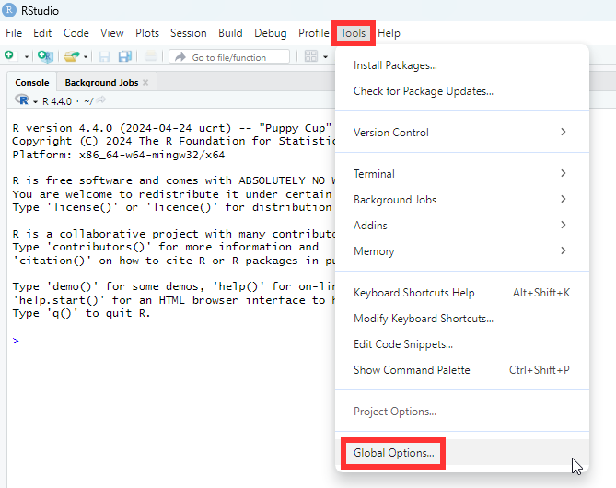
In 'Global Options' go to 'Publishing' and select 'Connect…':
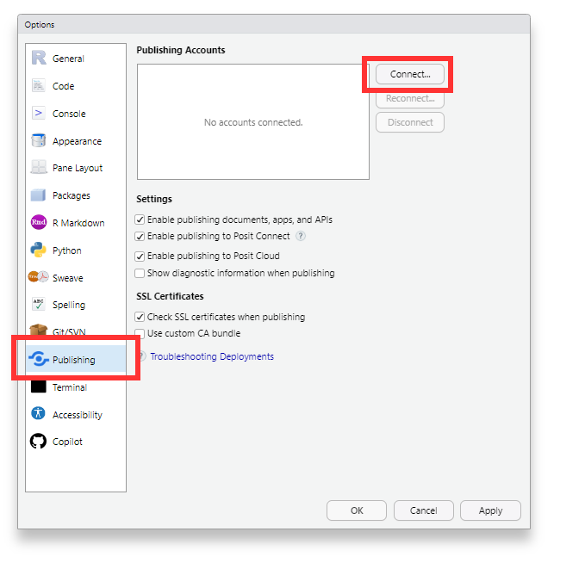
Connect to ShinyApps.io:
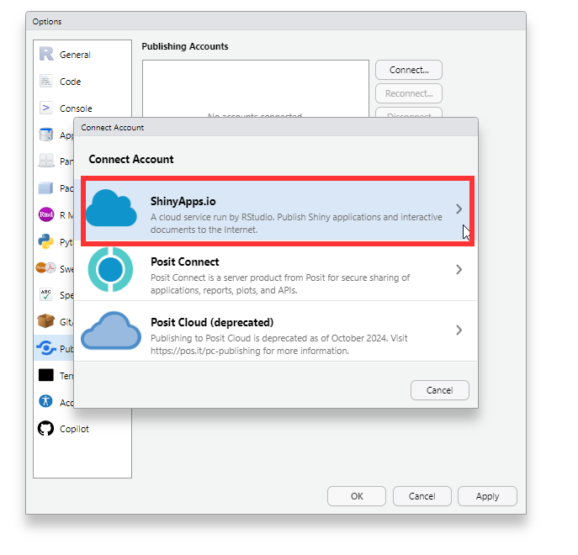

To connect, you will need to paste a token from your Shiny.io account into the 'Connect Account' box. Instructions are provided to guide you: go to your ShinyApps account, click on your name, select 'Tokens,' and then copy your secret token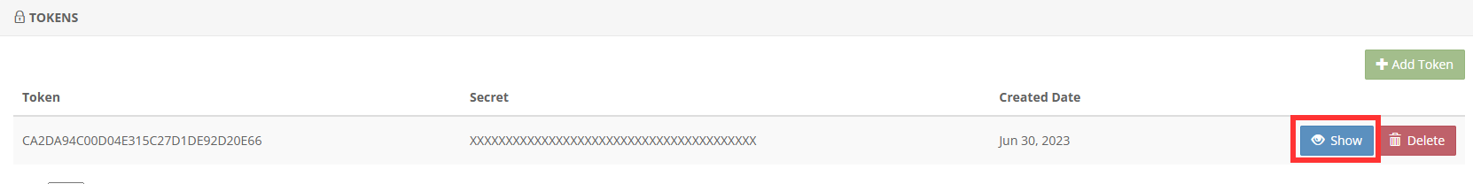

3.2 Uploading to Shiny IO

To upload the dashboard to Shiny.io for the first time or after making updates to the code, ensure you are in the project repository and then run the app.
You can run the app by opening the file 'Shiny_DB_v5.R', selecting all the code and clicking 'Run App'. This will deploy the app locally allowing you to verify that is functions as expected before publishing.
Once the app is deployed locally and open in the popout window, you will see an option to 'Publish' the app in the top right corner. Clicking this will open the following pop-up:
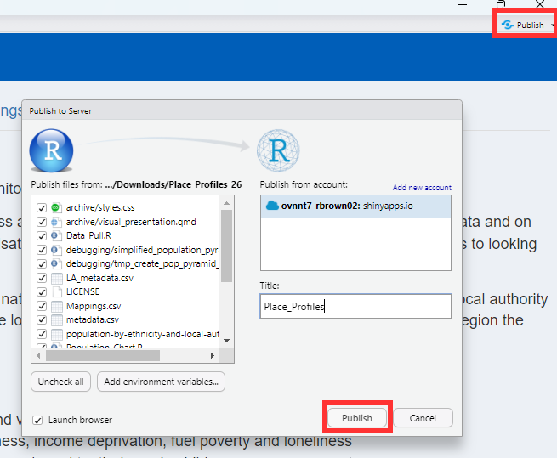

If you are republishing the app, ensure the title matches the one used previously. If the title is the same, you will prompted to confirm whether you want to overwrite the current app. Select 'Replace' and this will deploy the Shiny app, launching it in your browser.
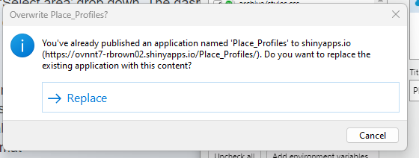

4 Common Issues

4.1 Values showing 'no data available'

Sometimes where a value box value says 'No data available' it may be because there is no data for the specific metrics and local authority. This can occur when local authority boundaries change. E.g. between the 2021 census and now, Cumbria has split into two separate Local Authorities – Cumberland and Westmorland & Furness – resulting in missing data for several metrics, including population estimates.
However, if data is missing for all local authorities, regions and England, this may indicate changes to the Fingertips indicator. The app uses the 'Indicator ID' from Fingertips to pull and filter data so it's possible that the indicator no longer exists or the ID has changed. To investigate, check Fingertips to confirm whether the indicator is still available or if the ID has been updated. You can use the 'Search for indicators' feature on Fingertips to explore further: https://fingertips.phe.org.uk/.

4.2 Deployment issues

If you're encountering deployment issues, a quick fix is to navigate to the rsconnect folder in your repository and delete all its contents. Occasionally, duplicate .dcf files can be generated, which may cause deployment problems. By removing all the files in the rsconnect folder, you essentially reset the deployment configuration, allowing for a fresh start.

